Saturday, March 7 & Sunday, March 8, 2026 * Third Sunday in Lent

Prayer of the Day
Let us pray. Merciful God, the fountain of living water, you quench our thirst and wash away our sin. Give us this water always. Bring us to drink from the well that flows with the beauty of your truth through Jesus Christ, our Savior and Lord, who lives and reigns with you and the Holy Spirit, one God, now and forever. Amen.

First Reading: Exodus 17:1-7

From the wilderness of Sin the whole congregation of the Israelites journeyed by stages, as the Lord commanded. They camped at Rephidim, but there was no water for the people to drink. The people quarreled with Moses and said, “Give us water to drink.” Moses said to them, “Why do you quarrel with me? Why do you test the Lord?” But the people thirsted there for water, and the people complained against Moses and said, “Why did you bring us out of Egypt, to kill us and our children and livestock with thirst?” So Moses cried out to the Lord, “What shall I do for this people? They are almost ready to stone me.” The Lord said to Moses, “Go on ahead of the people and take some of the elders of Israel with you; take in your hand the staff with which you struck the Nile and go. I will be standing there in front of you on the rock at Horeb. Strike the rock, and water will come out of it, so that the people may drink.” Moses did so, in the sight of the elders of Israel. He called the place Massah and Meribah, because the Israelites quarreled and tested the Lord, saying, “Is the Lord among us or not?”

Word of God, word of life.

Thanks be to God.

Psalm 95 (read responsively)
¹Come, let us sing to the Lord; let us shout for joy to the rock of our salvation.
²Let us come before God’s presence with thanksgiving and raise a loud shout to the Lord with psalms.
³For you, Lord, are a great God, and a great ruler above all gods.
⁴In your hand are the caverns of the earth; the heights of the hills are also yours.
⁵The sea is yours, for you made it, and your hands have molded the dry land.
⁶Come, let us worship and bow down, let us kneel before the Lord our maker.
⁷For the Lord is our God, and we are the people of God’s pasture and the sheep of God’s hand. Oh, that today you would hear God’s voice!
⁸“Harden not your hearts, as at Meribah, as on that day at Massah in the desert.
⁹There your ancestors tested me, they put me to the test, though they had seen my works.
¹⁰Forty years I loathed that generation, saying, ‘The heart of this people goes astray; they do not know my ways.’
¹¹Indeed I swore in my anger, ‘They shall never come to my rest.’ ”

Second Reading: Romans 5:1-11

Therefore, since we are justified by faith, we have peace with God through our Lord Jesus Christ, through whom we have obtained access to this grace in which we stand, and we boast in our hope of sharing the glory of God. And not only that, but we also boast in our afflictions, knowing that affliction produces endurance, and endurance produces character, and character produces hope, and hope does not put us to shame, because God’s love has been poured into our hearts through the Holy Spirit that has been given to us. For while we were still weak, at the right time Christ died for the ungodly. Indeed, rarely will anyone die for a righteous person—though perhaps for a good person someone might actually dare to die. But God proves his love for us in that while we still were sinners Christ died for us. Much more surely, therefore, since we have now been justified by his blood, will we be saved through him from the wrath of God. For if while we were enemies we were reconciled to God through the death of his Son, much more surely, having been reconciled, will we be saved by his life. But more than that, we even boast in God through our Lord Jesus Christ, through whom we have now received reconciliation.

Word of God, word of life.

Thanks be to God.

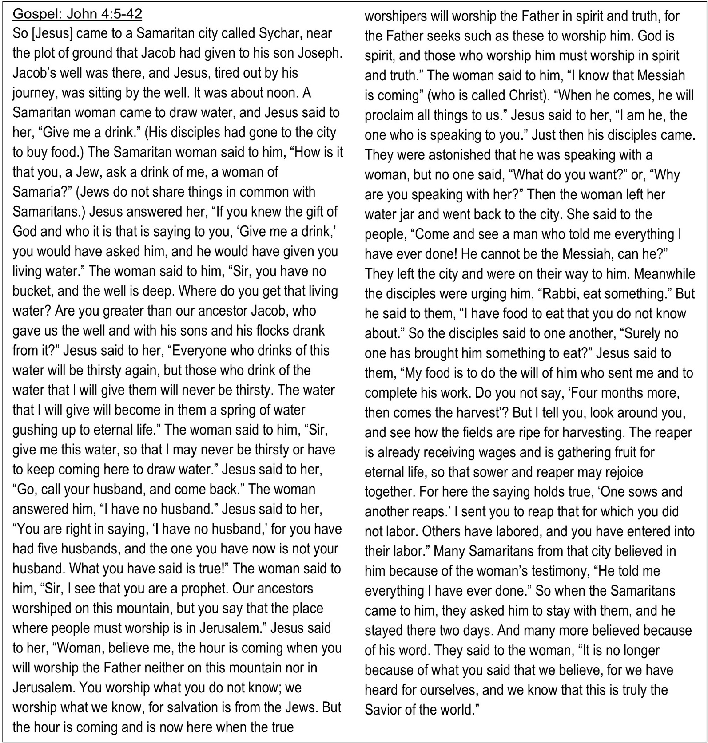

Prayers of Intercession – Lent 3 March 7 & 8, 2026
Reconciled by God’s mercy and sustained by God’s presence, let us pray for the world and its needs.
A brief silence.
O God, when suffering arises, preserve your church. Give to pastors, deacons, bishops, and all servants of your gospel the endurance that produces character and the hope that will never disappoint. Receive our prayers, O God.
Your mercy is great.
When the waters run dry, sustain this earth. Send water to places languishing with drought (especially), and bring relief to places damaged by floods (especially). Receive our prayers, O God.
Your mercy is great.
When quarrels ensue, soften our hearts. Quell hostilities between nations and peoples, and reconcile all humans across the lines of race, class, nationality, moral conviction, religion, and all else that divides or oppresses. Receive our prayers, O God.
Your mercy is great.
When your people thirst, satisfy their needs. Send water and food to all who need nourishment. Grant welcome to all who are excluded. Show your mercy to any in need ( especially [names].…and all other people or concerns we now name aloud on our lips or in the silence of our hearts.) Receive our prayers, O God.
Your mercy is great.
When we gather to worship, send us your Spirit. Renew our hearts through the joyful noise we make and bless the work of our church musicians and musical ensembles (especially). Receive our prayers, O God.
Your mercy is great.
O God, when death draws near, we rejoice in the promise of life with you. We remember all who have entered eternal rest especially (the Mandernack and the family of Deb Black) and we pray that you bring us the hope of sharing in your glory. Receive our prayers, O God.
Your mercy is great.
Receive our prayers, O God, through Jesus Christ, our strength and salvation.
Amen.

